Inventory application

GUI | Logistiek Elektronica

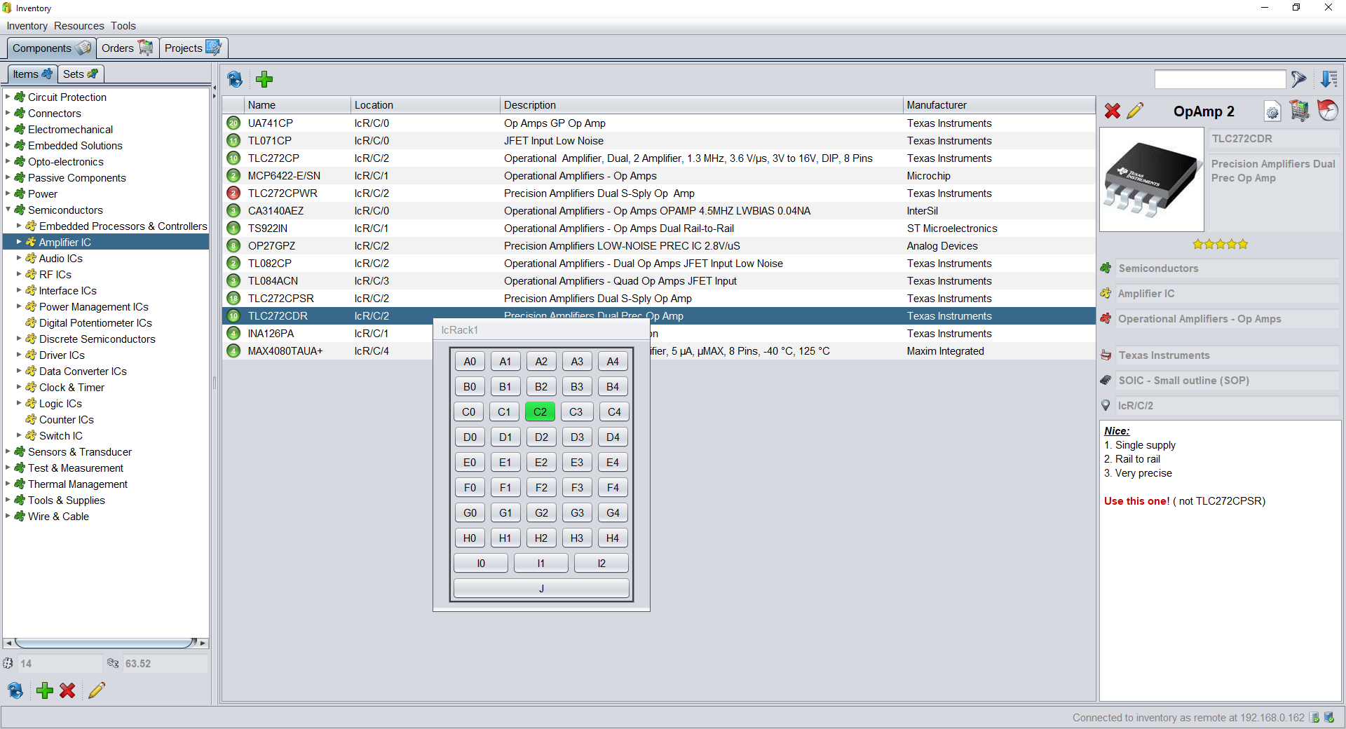

## Description

The application is created to keep an inventory of all the components of my personal stock. It can furthermore be used to create orders, and to keep track of PCB projects where components are used. The inventory is kept up-to-date by combining the input flow (manual or from orders), and the output flow of articles placed on PCBs.

## StatE

The application works and is used frequently. Using the app for finding components, ordering, and keeping track of PCBs has saved me a lot of time.  
Next steps:

* Orders for PCBs is not fully operational
* Projects can read KiCad PCBs but linking with known components can be better

## Details

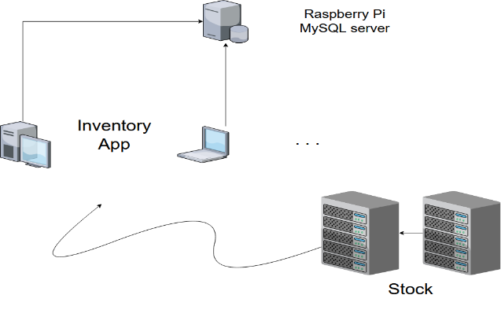The application connects with an MySQL database hosted on a Raspberry Pi 3.

Data is fetched and stored asynchronously to the database. This allows the app to run on different clients.

The application is written in Java using IntelliJ IDEA. The GUI is designed with the Swing library.

The InventoryApp contains three main panels:

1. Components: overview of all the components, categorized by their type. The location of the component can be shown by clicking the location cell.
2. Orders: categorized into ‘Planned’, ‘Ordered’ and ‘Received’. The app is able to create order files which can be imported immediately into the order page of a distributor.
3. Projects: keeps code and PCBs per project. Both can be opened from within the application. PCBs can be imported and linked with the known component library.

## MISC

#### Period

2017 – 2018

#### Github

https://github.com/WouterThys/InventoryApp

